Amazon S3 Encryption Explained
Amazon S3 encryption ensures that your data is secure while stored in an S3 bucket. Encryption helps protect sensitive data from unauthorized access.

✅ Types of S3 Encryption
There are two types of encryption in S3:
- Server-Side Encryption (SSE) – S3 encrypts data at rest (after upload).
- Client-Side Encryption – You encrypt data before uploading to S3.

1️Server-Side Encryption (SSE)
S3 automatically encrypts your data after it is uploaded and decrypts it when accessed.
🔹 Three methods of SSE:
Type | Description |  |  |  |  | Who Manages Keys?
SSE-S3 | Amazon S3 handles encryption using AES-256 |  |  |  |  | AWS (default option)
SSE-KMS | Uses AWS Key Management Service (KMS) for key control |  |  |  |  | Customer (via AWS KMS)
SSE-C | Customer provides encryption keys manually |  |  |  |  | Customer

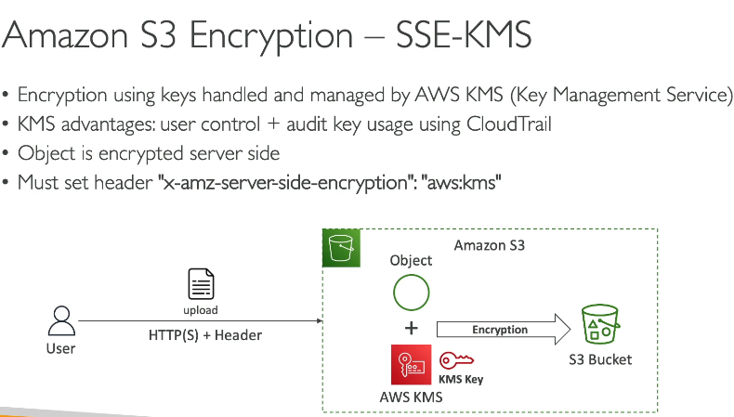
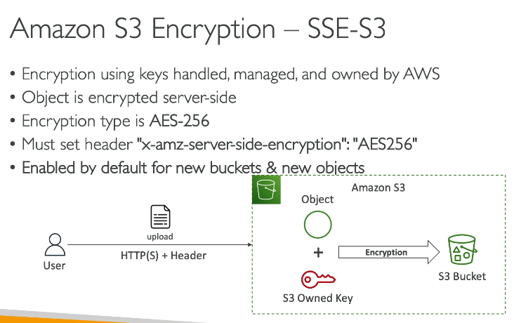

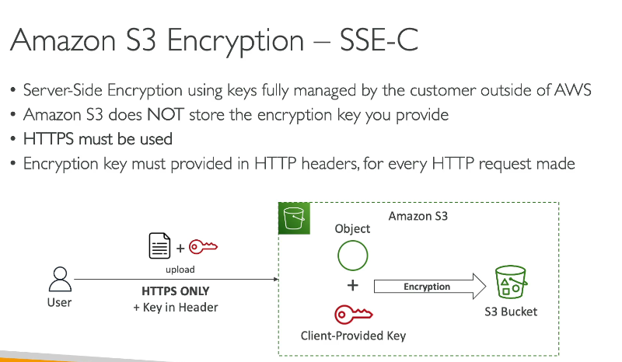

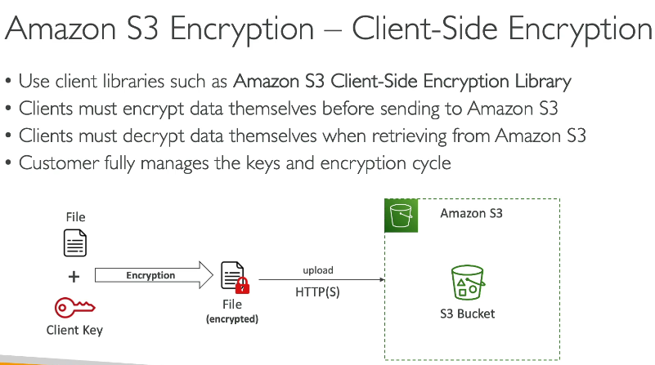
How to Enable Server-Side Encryption (SSE)
(A) Using the S3 Console
- Go to AWS S3 Console
- Select your bucket
- Click on "Properties" → "Default encryption"
- Choose the encryption type:
  - SSE-S3 (default, no setup needed)
  - SSE-KMS (requires KMS key)
  - SSE-C (must manually provide keys)
- Click Save
(B) While Uploading a File
- Go to your S3 bucket
- Click Upload → Add a file
- Under "Encryption", select:
  - SSE-S3 (recommended for basic security)
  - SSE-KMS (for controlled access via AWS KMS)
- Click Upload

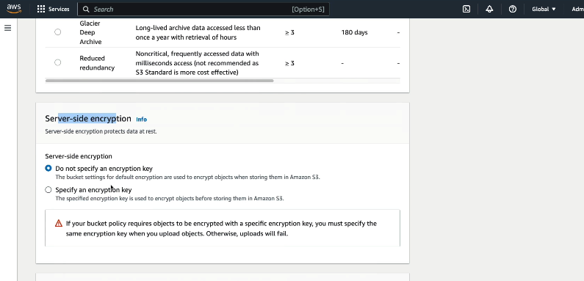
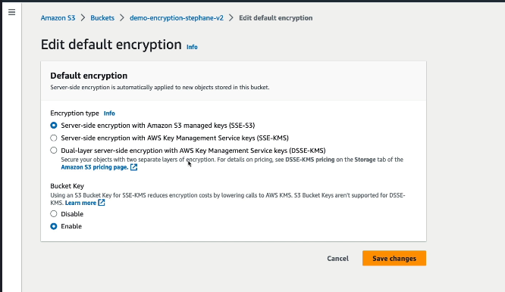

Amazon S3 Cross-Origin Resource Sharing (CORS) Explained
CORS (Cross-Origin Resource Sharing) in Amazon S3 allows your web application to access resources from an S3 bucket located in a different domain.
🚀 Scenario Example:
Suppose you have a frontend hosted on S3 (React/Angular app) and your backend API or assets (images, fonts, videos) stored in a different S3 bucket.
By default, browsers block cross-origin requests for security reasons. CORS helps you allow specific domains to access your S3 resources.
Scenario: Accessing Files from One S3 Bucket via Another S3 Static Website
This scenario involves hosting a static website in one S3 bucket and accessing files stored in another S3 bucket.

✅ Steps to Implement This Setup
1️ Create & Configure the First S3 Bucket (Website Hosting)
- Create an S3 bucket (e.g., my-website-bucket).
- Enable Static Website Hosting.
- Upload index.html and configure it as the default page.
- Set bucket policy to allow public access to the website.

2️Create & Configure the Second S3 Bucket (File Storage)
- Create another S3 bucket (e.g., my-storage-bucket).
- Upload files (e.g., image.jpg, data.json).
- Make these files publicly accessible using bucket policies or S3 Object ACLs.

3️ Enable Cross-Bucket Access (CORS & Bucket Policy)
- On my-storage-bucket (where files are stored):
  - Add a CORS Policy to allow requests from my-website-bucket.
  - Configure a Bucket Policy to allow my-website-bucket to access objects.

4️ Link Files in the Static Website (index.html)
- Modify index.html in my-website-bucket to reference files stored in my-storage-bucket using the public URLs.
Example:
📌 https://my-storage-bucket.s3.amazonaws.com/image.jpg

5️ Access the Website and Verify
- Open http://my-website-bucket.s3-website-us-east-1.amazonaws.com/ in a browser.
- Check if the files (e.g., image.jpg) from my-storage-bucket are loading correctly.
- If blocked, check CORS settings in my-storage-bucket.

Allow a Specific Website to Access S3 (Recommended)
[
{
"AllowedHeaders": ["Authorization"],
"AllowedMethods": ["GET"],
"AllowedOrigins": ["https://your-frontend.com"],
"ExposeHeaders": []
}
]
🔹 This allows only https://your-frontend.com to make GET requests.

Key Parameters in CORS Policy
Parameter | Description
AllowedOrigins | Defines which domains can access the S3 bucket.
AllowedMethods | Defines which HTTP methods (GET, POST, PUT, DELETE, etc.) are allowed.
AllowedHeaders | Defines which headers can be sent in a request.
ExposeHeaders | Defines which headers should be exposed to the browser after a request.

S3 Access Logs – Explanation & Scenario
📌 What are S3 Access Logs?
- Amazon S3 Access Logs provide detailed records of requests made to an S3 bucket.
- These logs help in auditing, troubleshooting, and monitoring access patterns.
- Logs are stored in a separate target S3 bucket.

✅ Scenario: Enable & Use S3 Access Logs
🛠️ Scenario: Monitoring Access to an S3 Bucket
You have an S3 bucket (my-secure-bucket) that stores sensitive files. You want to track who accessed or modified the files by enabling S3 Server Access Logging.

1️Create a Target Bucket for Logs
- Create an S3 bucket (my-logs-bucket) to store the access logs.
- Ensure this bucket is in the same AWS region.

2️Enable Access Logging on my-secure-bucket
- Open the AWS S3 Console.
- Go to my-secure-bucket > Properties.
- Enable Server Access Logging.
- Set the Target Bucket as my-logs-bucket.
- Specify a log prefix (e.g., logs/) to organize log files.

3️View & Analyze Logs
- Logs are saved as text files in my-logs-bucket/logs/.
- Each log entry includes:
  - Requester’s IP Address
  - Time of Access
  - Request Type (GET, PUT, DELETE, etc.)
  - User Agent (Browser, API, or CLI used)
  - HTTP Response Code (200, 403, 404, etc.)

Example log entry:
192.168.1.100 - [05/Mar/2025:12:00:00 +0000] GET /myfile.txt "Mozilla/5.0" 200
This means an IP (192.168.1.100) accessed myfile.txt successfully at 12:00 PM UTC.

4️Use Case – Detecting Unauthorized Access
- You notice multiple 403 Forbidden responses from an unknown IP.
- This indicates unauthorized access attempts.
- You can take action, such as:
  - Updating Bucket Policies.
  - Enabling IAM Restrictions.
  - Using AWS CloudTrail for deeper security audits.

✅ Key Benefits of S3 Access Logs
✔️ Security – Identify unauthorized access.
✔️ Troubleshooting – Diagnose failed requests.
✔️ Billing Analysis – Understand request volume to optimize costs.
✔️ Compliance – Maintain records for audits.

S3 Pre-Signed URLs – Explanation & Scenario
✅ What is an S3 Pre-Signed URL?
- A temporary, signed URL that allows users to securely access private S3 objects without making the bucket public.
- The URL expires after a set time (e.g., 15 mins, 1 hour).
- Can be used for secure file downloads/uploads.

🛠 Scenario: Secure File Sharing with Pre-Signed URL
You have a private S3 bucket (secure-docs-bucket) where you store confidential reports.
You want to allow Himanshu to download report.pdf for 30 minutes without making the bucket public.

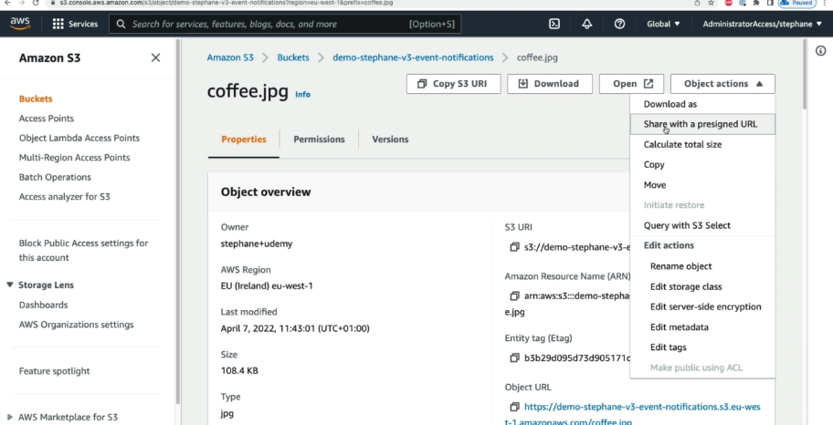

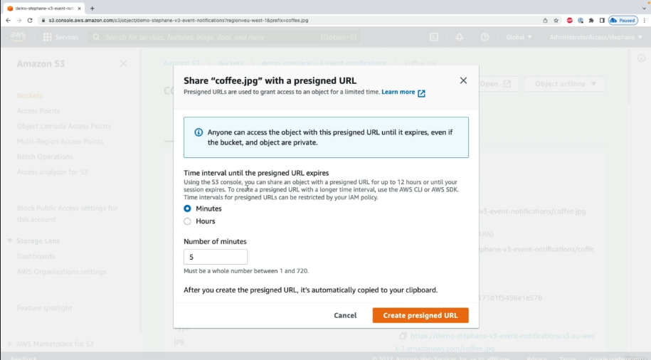
Glacier Vault Lock vs. S3 Object Lock
Both Glacier Vault Lock and S3 Object Lock are used for data retention and preventing accidental/malicious deletions, but they serve different purposes.

🛠 Glacier Vault Lock
🔹 Used for: Archival Data Compliance (e.g., legal, financial records).
🔹 Locks the entire vault in Amazon S3 Glacier.
🔹 Prevents changes to the vault's policies after they are locked.
🔹 WORM (Write Once Read Many) model: Once locked, no one can modify or delete archived data, even the AWS root user.
📍 Scenario for Glacier Vault Lock
- A bank stores customer financial records for compliance.
- To ensure data cannot be deleted for 7 years, they configure Vault Lock with a 7-year retention policy.
- Once locked, even the admin cannot modify the vault policy.

🛠 S3 Object Lock
🔹 Used for: Protecting Individual S3 Objects (files).
🔹 Prevents deletion/modification of specific objects for a defined time.
🔹 Supports WORM (Write Once, Read Many) storage.
🔹 Modes:
- Governance Mode: Protected objects can be deleted by admins with special permissions.
- Compliance Mode: No one, even AWS root user, can delete the object until the retention period expires.
📍 Scenario for S3 Object Lock
- A medical research company stores critical patient records in S3.
- They enable Object Lock (Compliance Mode) for 10 years to meet legal requirements.
- Even if an employee mistakenly tries to delete files, they remain protected.

🔹 Key Differences
Feature |  |  |  |  | Glacier Vault Lock |  |  |  |  |  | S3 Object Lock
Applies To |  |  |  |  | Entire Glacier Vault |  |  |  |  |  | Individual S3 Objects
Locking Level |  |  |  |  | Vault Policy |  |  |  |  |  | Per Object
WORM Compliance |  |  |  |  | ✅ Yes |  |  |  |  |  | ✅ Yes
Prevent Accidental Deletion |  |  |  |  | ✅ Yes |  |  |  |  |  | ✅ Yes
Retention Duration |  |  |  |  | Defined in Vault Policy |  |  |  |  |  | Per-object settings
Admin Deletion Possible? |  |  |  |  | ❌ No (Once Locked) |  |  |  |  |  | ✅ Yes (Governance Mode), ❌ No (Compliance Mode)

🚀 When to Use What?
✔️ Use Glacier Vault Lock if you need to protect an entire archive (e.g., compliance, regulatory storage).
✔️ Use S3 Object Lock if you need granular protection at the object level (e.g., legal documents, medical records).

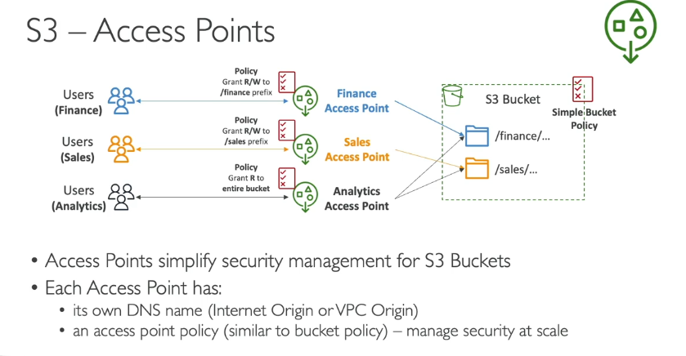

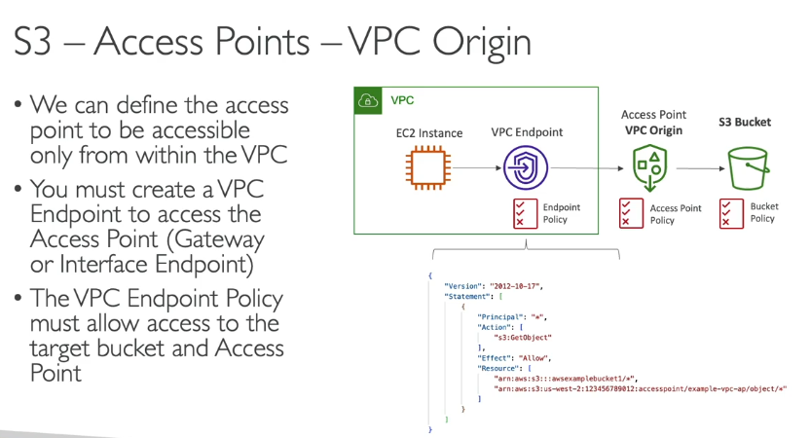
S3 Access Points – Simplified Bucket Access Management
🔹 What is an S3 Access Point?
Amazon S3 Access Points simplify and manage access to shared S3 buckets at scale by providing:
✅ Unique hostnames for accessing specific data.
✅ Separate IAM policies for different teams, applications, or VPCs.
✅ Better security by controlling access to subsets of bucket data.

🔹 Why Use S3 Access Points?
🔹 Multiple applications/users need different levels of access to the same bucket.
🔹 VPC-specific access control without exposing the entire bucket.
🔹 Easier access management instead of complex bucket policies.
Scenario-Based Guide: Using S3 Access Points for Secure Access
📍 Scenario: Controlling Access for Different Teams
Your company has an S3 bucket (company-docs-bucket) that stores financial reports. Three teams need different levels of access:
1️Finance Team → Full read/write access to financial reports.
2️Developers → Access only from a private VPC (not the internet).
Instead of using a complex bucket policy, you will create S3 Access Points to manage access easily.

✅ Steps to Implement S3 Access Points
🔹 Step 1: Create an S3 Bucket
- Go to the AWS Management Console → Open S3.
- Click "Create Bucket" and name it company-docs-bucket.
- Enable Bucket Versioning (optional, for data recovery).
- Click "Create".

🔹 Step 2: Create Access Points for Different Teams
1️Create Access Point for Finance Team
- Go to Amazon S3 → Click Access Points → Create Access Point.
- Name: finance-access
- Bucket: Select company-docs-bucket
- Enable Internet Access (for external access)
- Attach an IAM Policy to allow read/write access for finance users.
2 Create Access Point for Developers (VPC-Restricted)
- Go to Amazon S3 → Click Access Points → Create Access Point.
- Name: developer-access
- Bucket: company-docs-bucket
- Select Restrict Access to VPC → Choose your VPC ID.
- Attach an IAM Policy to allow read-only access but only within the VPC.

🔹 Step 3: Assign IAM Policies to Access Points
✅ Finance Team Policy (Read/Write)
{
"Effect": "Allow",
"Principal": {"AWS": "arn:aws:iam::123456789012:user/finance-user"},
"Action": ["s3:GetObject", "s3:PutObject"],
"Resource": "arn:aws:s3:us-east-1:123456789012:accesspoint/finance-access/object/*"
}
✅ Developer Policy (VPC-Only Read Access)
{
"Effect": "Allow",
"Principal": "*",
"Action": ["s3:GetObject"],
"Resource": "arn:aws:s3:us-east-1:123456789012:accesspoint/developer-access/object/*",
"Condition": {
"StringEquals": {
"aws:SourceVpc": "vpc-0abcd1234efgh5678"
}
}
}

🔹 Step 4: Users Access Data via Access Points
- Finance Team uses:
finance-access-123456789012.s3-accesspoint.us-east-1.amazonaws.com
- Developers use (from VPC only):
developer-access-123456789012.s3-accesspoint.us-east-1.amazonaws.com

🚀 Benefits of Using S3 Access Points
✔ Simplifies access management instead of modifying bucket policies.
✔ Restricts developer access to VPC for security.
✔ Enables multiple teams to access the same bucket with different permissions.

What is S3 Multi-Region Access Points?
S3 Multi-Region Access Points enable applications to access data from multiple S3 buckets across different AWS Regions through a single global endpoint. This helps improve performance, availability, and resilience by routing requests to the nearest or most efficient region.

📍 Real-Life Scenario: Global Data Access for a Media Streaming Company
A global media streaming company stores video files in two AWS S3 buckets:
- Bucket 1 in us-east-1 (Virginia)
- Bucket 2 in ap-south-1 (Mumbai)
Users from North America should access data from the Virginia bucket, while users from India should access data from the Mumbai bucket to reduce latency. Instead of configuring separate endpoints, the company creates an S3 Multi-Region Access Point to handle this automatically.

Benefits of Using S3 Multi-Region Access Points
✔ Automatic routing to the closest region for better performance.
✔ High availability—if one region fails, traffic is routed to another.
✔ Simplified architecture—a single global endpoint instead of managing multiple regional S3 URLs.
✔ Improved compliance—data stays within specific regions as needed.

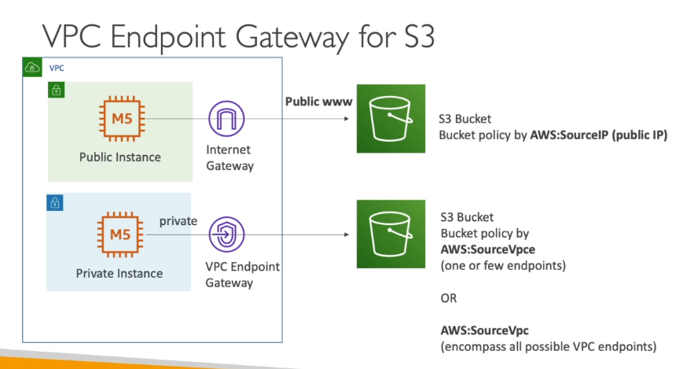

If you encounter an error while enabling MFA Delete using the AWS CLI, the most likely reason is that MFA Delete can only be enabled when versioning is enabled, and it requires the root user.

🔹 What is AWS Snow Family?
AWS Snow Family is a set of physical devices designed to help move large amounts of data in and out of AWS when network transfer is slow, expensive, or impractical. These devices are rugged, portable, and secure for edge computing, data migration, and storage expansion.

📍 AWS Snow Family Services & Use Cases
AWS Snow Family Service | Purpose | Example Use Case
AWS Snowcone | Smallest & ultra-portable | Ship 8 TB of IoT sensor data from a remote oil rig to AWS
AWS Snowball Edge | High-capacity & computing power | Transfer 80 TB of video footage from a film studio to AWS
AWS Snowmobile | Massive data transfer (100 PB) | Move an entire data center to AWS

🛠️ How AWS Snow Family Works?
1️Order a Snow Device
📌 Use the AWS Console to request Snowcone, Snowball, or Snowmobile.
✔ Choose storage capacity and select encryption options.
2️AWS Ships the Device
📌 AWS ships the device pre-configured to your location.
✔ These devices are tamper-proof & secured with encryption.
3️Load Data onto the Device
📌 Connect the device to your network and copy data.
✔ Supports S3, NFS, and CLI tools for data transfer.
4️Ship the Device Back to AWS
📌 Once data is copied, return the device to AWS.
✔ AWS automatically transfers your data to S3 upon arrival.
5️Data Available in AWS
📌 After migration, you can access data in AWS S3.

📍 Real-Life Scenarios for AWS Snow Family
🎥 Scenario 1: Film Studio (AWS Snowball Edge)
A film production studio in Los Angeles records high-resolution 8K videos (80 TB).
🔹 The internet is too slow to upload data to AWS S3.
✅ They order an AWS Snowball Edge, copy their data, and ship it back to AWS.
🔹 AWS imports the data to Amazon S3, making it instantly available for cloud processing.

🏭 Scenario 2: Oil Rig Remote Sensors (AWS Snowcone)
An oil company in a remote location has IoT sensors that generate terabytes of data.
🔹 No reliable internet is available.
✅ They use an AWS Snowcone to collect and process data locally.
🔹 Once full, they ship it to AWS, and AWS automatically uploads the data.

🏢 Scenario 3: Data Center Migration (AWS Snowmobile)
A large banking company has 10 PB of financial data in an on-prem data center.
🔹 Uploading via the internet would take years and cost millions.
✅ They order an AWS Snowmobile (a 45-foot truck).
🔹 AWS transfers the data securely and moves it to Amazon S3 within weeks.

✅ Key Benefits of AWS Snow Family
✔ Faster Data Transfers – No reliance on slow internet speeds.
✔ Secure – All data is encrypted with AWS KMS.
✔ Cost-Effective – Avoid high network transfer costs.
✔ Edge Computing – Process data locally before transferring it.

📌 Conclusion
AWS Snow Family is perfect for companies with large data volumes that need fast, secure, and cost-effective transfers to AWS. It helps in data center migrations, edge computing, and cloud integration.

🔹 What is Amazon FSx?
Amazon FSx is a fully managed file storage service that provides high-performance, scalable, and secure file systems in AWS. It allows you to run Windows, Lustre, NetApp ONTAP, and OpenZFS file systems without managing hardware or software.

📍 Amazon FSx File System Types & Use Cases
FSx Type |  |  | Purpose |  |  | Example Use Case
FSx for Windows File Server |  |  | Windows-native file system |  |  | File sharing for Windows-based apps & Active Directory (AD) integration
FSx for Lustre |  |  | High-speed parallel file system |  |  | Machine Learning (ML), Big Data, High-Performance Computing (HPC)
FSx for NetApp ONTAP |  |  | Enterprise-grade hybrid cloud storage |  |  | Disaster recovery, database backups, multi-protocol support
FSx for OpenZFS |  |  | ZFS-based file storage with snapshots |  |  | Low-latency workloads, DevOps environments

🛠️ How Amazon FSx Works?
1️Choose Your FSx File System Type
📌 Go to AWS Console → Navigate to Amazon FSx
✔ Select FSx for Windows, Lustre, NetApp ONTAP, or OpenZFS
2️Configure the File System
📌 Define storage capacity, throughput, and networking options
✔ Choose between Single-AZ or Multi-AZ deployment
3️Connect FSx to Your Workloads
📌 Mount the FSx file system to EC2 instances, on-prem servers, or Kubernetes clusters
✔ Use SMB, NFS, or Lustre protocols to access data
4️Optimize Performance & Security
📌 Enable data encryption, automatic backups, and access control
✔ Integrate with AWS IAM, VPC, and Active Directory
5️Scale & Monitor Your File System
📌 Monitor usage using AWS CloudWatch & FSx Console
✔ Scale storage and performance as needed

📍 Real-Life Scenarios for Amazon FSx
🖥️ Scenario 1: Windows File Sharing (FSx for Windows)
A company with hundreds of Windows users needs a centralized file storage system.
🔹 They use FSx for Windows to host their Windows file shares.
✅ Users can securely access files using SMB, and FSx integrates with Active Directory (AD).

📊 Scenario 2: High-Performance Data Processing (FSx for Lustre)
A research lab needs high-speed storage for running machine learning models.
🔹 They choose FSx for Lustre because it provides low-latency & high-throughput.
✅ The lab connects FSx for Lustre to Amazon S3, allowing fast access to training data.

🏢 Scenario 3: Hybrid Storage Solution (FSx for NetApp ONTAP)
A financial company wants hybrid storage for on-prem & AWS workloads.
🔹 They deploy FSx for NetApp ONTAP, which supports multi-protocol access (NFS, SMB, iSCSI).
✅ Their on-prem and cloud applications can access the same storage seamlessly.

📂 Scenario 4: DevOps & Backup Storage (FSx for OpenZFS)
A software company needs a fast, snapshot-enabled file system for their DevOps team.
🔹 They choose FSx for OpenZFS for low-latency access and easy snapshots for backups.
✅ The team can quickly restore old configurations and run CI/CD workflows efficiently.

✅ Key Benefits of Amazon FSx
✔ Managed Service – AWS handles backups, scaling, and patching.
✔ High Performance – Designed for fast & low-latency workloads.
✔ Flexible Storage Options – Choose the best file system based on your needs.
✔ Hybrid & On-Prem Integration – Works with on-prem servers & cloud.
✔ Secure & Compliant – Supports IAM, VPC, encryption, and auditing.

📌 Conclusion
Amazon FSx is the best choice for organizations that need scalable, high-performance, and managed file storage in AWS. It supports various workloads, including Windows apps, AI/ML, hybrid cloud, and DevOps environments.

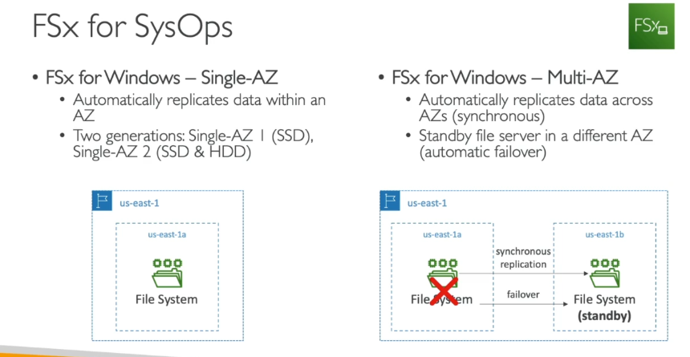

What is AWS Storage Gateway?
AWS Storage Gateway is a hybrid cloud storage service that allows on-premises applications to integrate seamlessly with AWS cloud storage. It provides low-latency access to cloud data while offering the scalability and durability of AWS storage services.

📍 Types of Storage Gateways & Use Cases
Storage Gateway Type | Purpose | Example Use Case
File Gateway | Provides file-based storage for AWS (NFS & SMB protocols) | Backup & archive, hybrid cloud file storage
Volume Gateway | Creates iSCSI volumes backed by AWS | Disaster recovery, on-prem block storage
Tape Gateway | Replaces physical tape libraries with virtual tapes stored in AWS | Backup and archiving (e.g., for compliance)

